**Wildridings Primary School**



**Writing Policy**

**Our Aims:**

• For writing to be seen as purposeful and enjoyable

• For each child to see themselves as a confident and successful writer

• For each child to achieve the level of writing of which they are capable

• For writing to be developed across a range of meaningful contexts

• For there to be a broad curriculum offering the full spectrum of writing genres

• For each child to develop the necessary writing skills to be a competent writer with an understanding of the basics – spelling, grammar, handwriting and punctuation

• For writing to be seen as an essential life skill.

**At Wildridings we recognise that**:

• Writing is pre-requisite for educational and social progress

• Writing empowers pupils to communicate both creatively and imaginatively

• Writing is essential for independent learning

• The mastery of writing is essential in most aspects of everyday life.

**Our approach:**

We want our children to become independent, confident writers. With this in mind, our staff use a blended approach to help support and achieve the best for all pupils. We try to use a ‘hook’ to engage and motivate our children’s writing. Through our teaching, we cover a wide range of genres from Nursery through to Year 6.  We encourage children to be creative and compose writing for a range of purposes. As reading and writing are closely linked we use a variety of high-quality texts and stimulus to inspire our children’s writing.

Grammar and punctuation are taught through blended and explicit English sessions and children are given the opportunity to apply these skills in context. A route map to highlight the process is used to aid planning (see below). Staff use prior knowledge and assessments, such as ‘Cold Tasks’, as tool when introducing a new purpose of writing. At this point, next steps are identified and these are used to inform planning. At the end of the unit children complete a ‘Hot Write’, which is an independent piece of writing with minimal guidance. This piece of writing is moderated in year groups using moderation grids. Each unit plans for an editing lesson where the pupils are taught key editing skills and are given opportunities to apply these to their independent writing.

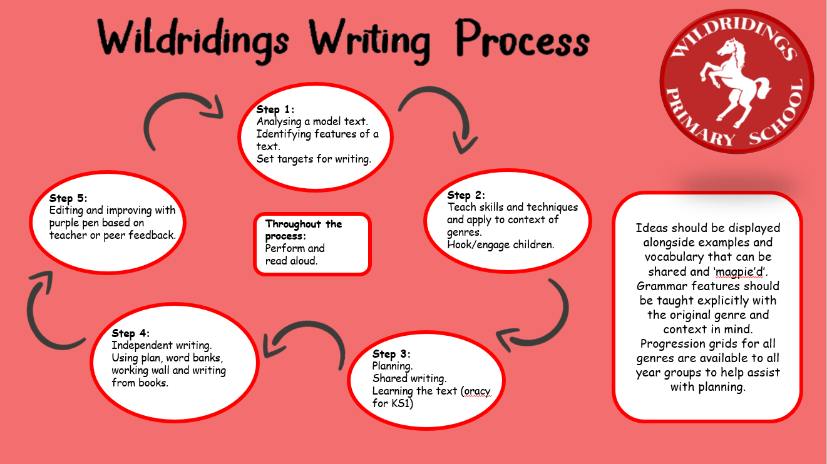

**Spelling**

Across the school, teachers use the Sounds-write approach to teach spellings linked to year group statutory guidance. In EYFS and KS1, the focus is on spelling using the initial and extended code. In KS2 the focus is on polysyllabic words and morphology. Throughout lessons there are plenty of opportunities to revisit and to embed skills and knowledge.

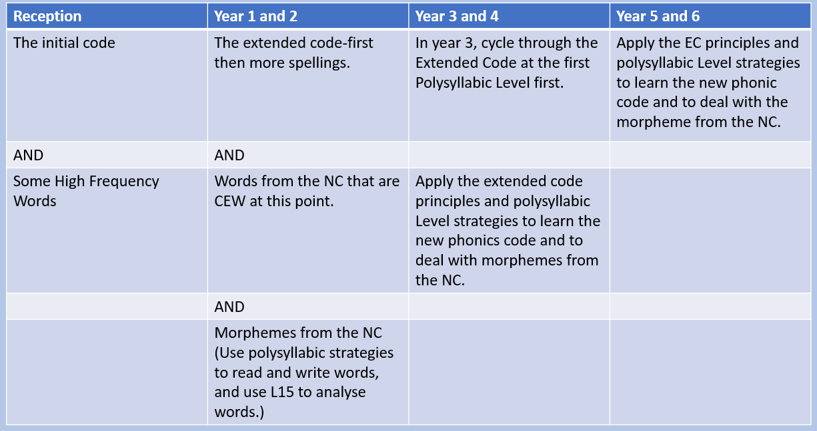

**Handwriting**

1. **Handwriting Aims**

At Wildridings, our aims in teaching handwriting are that the pupils will:

* Achieve a neat, legible style with correctly formed letters in accordance with the cursive font;
* Develop flow and speed;
* Enjoy learning and develop their handwriting with a sense of achievement and pride.
* Eventually produce the letters automatically and in their independent writing.

Handwriting is practised regularly across the school. In Reception, pupils print letters. From Year 1, when ready, the children are taught to join letters using different strokes. To support children’s formation and presentation pupils use mid lines.

Pupils should be taught to sit correctly at a table, holding a pencil comfortably and correctly.

Sitting position

Paper position for right-handed children

Sit with a straight back, not leaning over the page

The table reaches to below elbow height



Sit right back in the seat

Keep feet flat on the floor

Pull the chair close in to the table

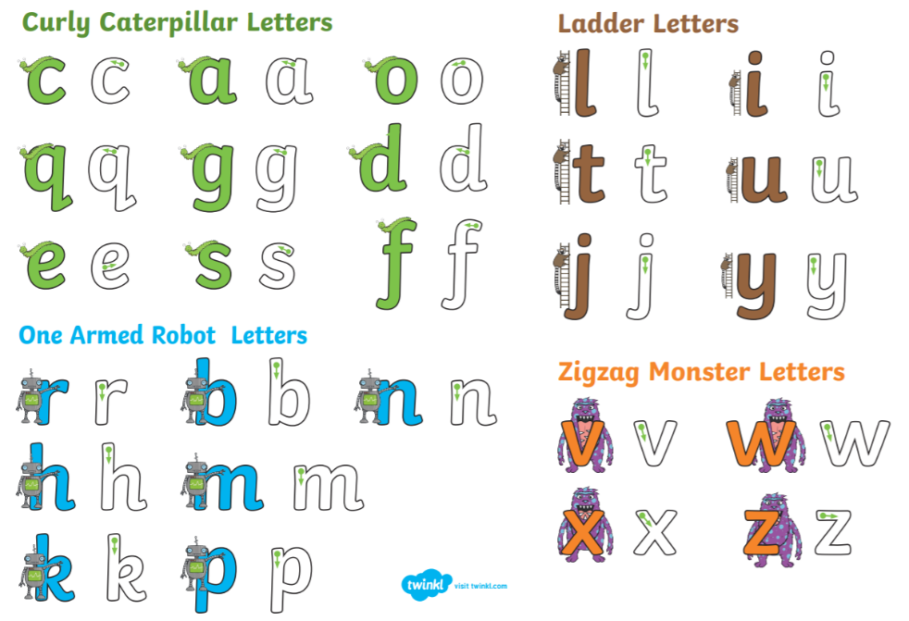Letter families:

Lower case letters:

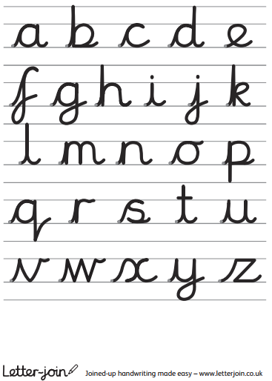

The tripod pencil grip

Both right and left-handed children should be encouraged to use the tripod grip which allows the pen/pencil to be held securely whilst allowing controlled movements of the pen/pencil nib.



1) Grip the pencil with your index finger and thumb with the nib pointing away.

2) With your free hand, spin the pencil from underneath.

3) Use your middle finger to support the underside of the pencil.